MA 322 (2021) Scientific Computing Lab Lab 06

**Name:** Udandarao Sai Sandeep

**Roll Number:** 180123063

**Dept.:** Mathematics and Computing

**Q1.**

The **Euler’s method** was followed to approximate the solution of the **Initial Value problems.**

(a) Number of nodes = 3, h = 0.5

|  |  |
| --- | --- |
| x | Estimate value of y(x) |
| 0 | **1** |
| 0.5 | **1.183940** |
| 1 | **1.436252** |

(b) Number of nodes = 3, h = 0.5

|  |  |
| --- | --- |
| x | Estimate value of y(x) |
| 1 | **2** |
| 1.5 | **2.333333** |
| 2 | **2.708333** |

(c) Number of nodes = 5, h = 0.25

|  |  |
| --- | --- |
| x | Estimate value of y(x) |
| 2 | **2** |
| 2.25 | **2.207107** |
| 2.5 | **2.490999** |
| 2.75 | **2.854680** |
| 3 | **3.302596** |

(d) Number of nodes = 5, h = 0.25

|  |  |
| --- | --- |
| x | Estimate value of y(x) |
| 2 | **2** |
| 2.25 | **1.227324** |
| 2.5 | **0.832150** |
| 2.75 | **0.570447** |
| 3 | **0.378827** |

**Q2.**

By using the given solutions to the IVP’s, the corresponding error values was calculated

(a) Number of nodes = 3, h = 0.5

|  |  |  |
| --- | --- | --- |
| x | Estimate value of y(x) | Error |
| 0 | **1** | **0** |
| 0.5 | **1.18394** | **0.030083** |
| 1 | **1.436252** | **0.053628** |

(b) Number of nodes = 3, h = 0.5

|  |  |  |
| --- | --- | --- |
| x | Estimate value of y(x) | Error |
| 1 | **2** | **0** |
| 1.5 | **2.333333** | **0.020769** |
| 2 | **2.708333** | **0.033324** |

(c) Number of nodes = 5, h = 0.25

|  |  |  |
| --- | --- | --- |
| x | Estimate value of y(x) | Error |
| 2 | **2** | **0** |
| 2.25 | **2.207107** | **0.037014** |
| 2.5 | **2.490999** | **0.073453** |
| 2.75 | **2.85468** | **0.110513** |
| 3 | **3.302596** | **0.148690** |

(d) Number of nodes = 5, h = 0.25

|  |  |  |
| --- | --- | --- |
| x | Estimate value of y(x) | Error |
| 2 | **2** | **0** |
| 2.25 | **1.227324** | **0.175875** |
| 2.5 | **0.83215** | **0.18426** |
| 2.75 | **0.570447** | **0.167563** |
| 3 | **0.378827** | **0.150860** |

**Q3.**

Similarly, following as above, we have the following results:

(a)

Number of nodes = 21, h = 0.05

|  |  |  |  |
| --- | --- | --- | --- |
| x | Estimate value of y(x) | Actual value of y(x) | Error value |
| 1 | **-1** | **-1** | **0** |
| 1.05 | **-0.950000** | **-0.952381** | **0.002381** |
| 1.1 | **-0.904535** | **-0.909091** | **0.004555** |
| 1.15 | **-0.863007** | **-0.869565** | **0.006558** |
| 1.2 | **-0.824917** | **-0.833333** | **0.008416** |
| 1.25 | **-0.789848** | **-0.800000** | **0.010152** |
| 1.3 | **-0.757447** | **-0.769231** | **0.011784** |
| 1.35 | **-0.727415** | **-0.740741** | **0.013326** |
| 1.4 | **-0.699495** | **-0.714286** | **0.014791** |
| 1.45 | **-0.673467** | **-0.689655** | **0.016188** |
| 1.5 | **-0.649141** | **-0.666667** | **0.017525** |
| 1.55 | **-0.626350** | **-0.645161** | **0.018811** |
| 1.6 | **-0.604949** | **-0.625000** | **0.020051** |
| 1.65 | **-0.584812** | **-0.606061** | **0.021249** |
| 1.7 | **-0.565825** | **-0.588235** | **0.022410** |
| 1.75 | **-0.547890** | **-0.571429** | **0.023539** |
| 1.8 | **-0.530918** | **-0.555556** | **0.024637** |
| 1.85 | **-0.514832** | **-0.540541** | **0.025708** |
| 1.9 | **-0.499561** | **-0.526316** | **0.026754** |
| 1.95 | **-0.485043** | **-0.512821** | **0.027778** |
| 2 | **-0.47122** | **-0.500000** | **0.028780** |

(b)

Number of nodes was set to 21.

The function behavior at x = 1.052, y = 1.555 and x = 1.978 is as follows:

|  |  |  |  |
| --- | --- | --- | --- |
| x | Estimated value of y(x) (Interpolation) | Actual value of y(x) | Error value |
| 1.052 | **-0.948099** | **-0.950570** | **0.002472** |
| 1.555 | **-0.624150** | **-0.643086** | **0.018937** |
| 1.978 | **-0.477219** | **-0.505561** | **0.028342** |

**Q4.**

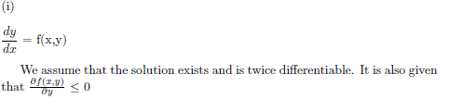

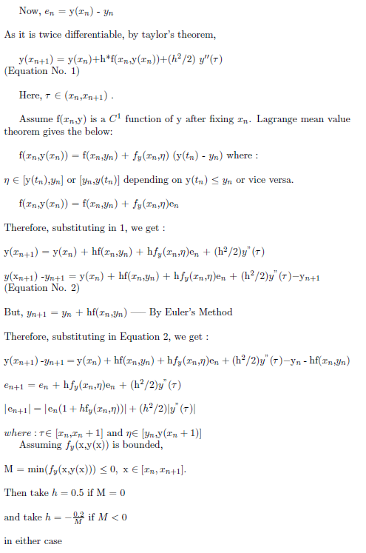



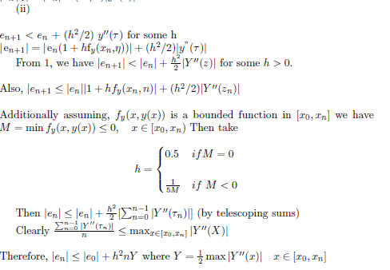

**Q5.**

**λ = -20.**

**The value of h has been set to 0.5.**

**Number of Nodes =7**

Function Approximation at **x = 3**:

For x = 3, the **estimated** value of y is: **-785.2886498351329**

For x = 3, the **actual** value of y is: **0.1411200080598672**

The **error** between actual and real value is: **785.4297698431927**

It can be seen that error is very large.

Now, if we decrease the value of h to **0.05**, we have the following results:

Function Approximation at x = 3:

For x = 3, the **estimated** value of y is: **0.14133753721110437**

For x = 3, the **actual** value of y is: **0**.**1411200080598672**

The **error** between actual and real value is: **0.00021752915123715577**

So, choosing a **lesser** value of **h** results in great reduction in error values.

**h = 0.5**

Now, Y = $\frac{1}{2} max⁡|-sin⁡(x)|$ where x ϵ [0,3].

So, the maximum error bound is: err = nh2Y **= 0.75** (h = 0.5)

The **actual** **absolute** **error** is much **greater** than the **theoretical** **upper** **bound** for error.

However, this **does not contradict** the validity of theorem proved in Q4. In **Q4**, it was stated that **there exists a h** such that 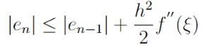, with the help of which the theoretical upper bound was calculated. This theorem is **indeed valid for that particular value of h**, and **not for every possible value of h**. in **Q5**, the value of h was fixed to **0.5**, fairly large value, which resulted in **large** error. However, when the value of h was **decreased**, the error became much **smaller**.